|  |  |
| --- | --- |
| **Gerb-BMSTU_01** | **Министерство науки и высшего образования Российской Федерации**  Калужский филиал  федерального государственного бюджетного  образовательного учреждения высшего образования  ***«Московский государственный технический университет имени Н.Э. Баумана (национальный исследовательский университет)»***  ***(КФ МГТУ им. Н.Э. Баумана)*** |

**ФАКУЛЬТЕТ** ***ИУК «Информатика и управление»***

**КАФЕДРА** \_\_***ИУК4 «Программное обеспечение ЭВМ, информационные технологии»***

**ЛАБОРАТОРНАЯ РАБОТА №3**

**«Разработка Android-приложений с несколькими activity. Работа с intent-объектами»**

**ДИСЦИПЛИНА: «Разработка мобильного ПО»**

|  |  |  |
| --- | --- | --- |
| Выполнил: студент гр. ИУК4-62Б | | \_\_\_\_\_\_\_\_\_\_\_\_\_\_\_\_\_ ( Карельский М.К. )  (Подпись) |
| Проверил: | | \_\_\_\_\_\_\_\_\_\_\_\_\_\_\_\_\_ ( Шаматрин А.Г. )  (Подпись) |
| Дата сдачи (защиты):  Результаты сдачи (защиты): | | |
|  | - Балльная оценка:  - Оценка: | |

Калуга, 2023

**Цель:** приобретение практических навыков разработки приложений с несколькими Activity и Intent-объектами.

**Задачи:**

1. Изучить механизм создания многоэкранных приложений на платформе Android
2. Научиться разрабатывать приложения с использованием явного и неявного вызова классов
3. Понять особенности реализации Android-приложений с использованием Intent-объектов

**Задание:**

Задание состоит из двух проектов. Все проекты используют Intent объекты. В первом проекте все требуемые параметры устанавливаются в главном Activity и результат отображается на второстепенном Activity. Во втором проекте результат отображается на главном Activity, а для задания соответствующих параметров используется несколько второстепенных Activity. Один из проектов реализовать с использованием неявного вызова (action), второй проект реализовать с явным вызовом класса(-ов).

**Вариант 14**

С помощью компонентов RadioButton задать не менее 6 размеров текста, компоненты ImageButton определяют палитру цветов 4х4 (один цвет случайный) для задания цвета текста, Button определяют выравнивание текста по горизонтали (слева, справа, по центру). Отобразить текст в компоненте TextView с заданными параметрами.

**Листинг:**

**Версия 1:**

***activity\_main.xml***

*<?*xml version="1.0" encoding="utf-8"*?>*<androidx.constraintlayout.widget.ConstraintLayout xmlns:android="http://schemas.android.com/apk/res/android"  
 xmlns:app="http://schemas.android.com/apk/res-auto"  
 xmlns:tools="http://schemas.android.com/tools"  
 android:layout\_width="match\_parent"  
 android:layout\_height="match\_parent"  
 tools:context=".MainActivity">  
  
 <RadioGroup  
 android:id="@+id/radioGroup"  
 android:layout\_width="150dp"  
 android:layout\_height="290dp"  
 android:layout\_marginStart="50dp"  
 android:layout\_marginTop="25dp"  
 app:layout\_constraintStart\_toStartOf="parent"  
 app:layout\_constraintTop\_toTopOf="parent">  
  
 <RadioButton  
 android:id="@+id/radioButtonSize\_1"  
 android:layout\_width="match\_parent"  
 android:layout\_height="wrap\_content"  
 android:checked="true"  
 android:onClick="onSizeButtonClicked"  
 android:text="Размер 1"  
 android:textSize="12sp" />  
  
 <RadioButton  
 android:id="@+id/radioButtonSize\_2"  
 android:layout\_width="match\_parent"  
 android:layout\_height="wrap\_content"  
 android:onClick="onSizeButtonClicked"  
 android:text="Размер 2"  
 android:textSize="14sp" />  
  
 <RadioButton  
 android:id="@+id/radioButtonSize\_3"  
 android:layout\_width="match\_parent"  
 android:layout\_height="wrap\_content"  
 android:onClick="onSizeButtonClicked"  
 android:text="Размер 3"  
 android:textSize="16sp" />  
  
 <RadioButton  
 android:id="@+id/radioButtonSize\_4"  
 android:layout\_width="match\_parent"  
 android:layout\_height="wrap\_content"  
 android:onClick="onSizeButtonClicked"  
 android:text="Размер 4"  
 android:textSize="18sp" />  
  
 <RadioButton  
 android:id="@+id/radioButtonSize\_5"  
 android:layout\_width="match\_parent"  
 android:layout\_height="wrap\_content"  
 android:onClick="onSizeButtonClicked"  
 android:text="Размер 5"  
 android:textSize="20sp" />  
  
 <RadioButton  
 android:id="@+id/radioButtonSize\_6"  
 android:layout\_width="match\_parent"  
 android:layout\_height="wrap\_content"  
 android:onClick="onSizeButtonClicked"  
 android:text="Размер 6"  
 android:textSize="22sp" />  
 </RadioGroup>  
  
 <ImageButton  
 android:id="@+id/darkRedImageButton"  
 android:layout\_width="50dp"  
 android:layout\_height="50dp"  
 android:layout\_marginStart="70dp"  
 android:layout\_marginTop="25dp"  
 android:background="#a50200"  
 android:contentDescription="TODO"  
 android:onClick="onColorClicked"  
 app:layout\_constraintStart\_toStartOf="parent"  
 app:layout\_constraintTop\_toBottomOf="@+id/radioGroup" />  
  
 <ImageButton  
 android:id="@+id/redImageButton"  
 android:layout\_width="50dp"  
 android:layout\_height="50dp"  
 android:layout\_marginStart="25dp"  
 android:layout\_marginTop="25dp"  
 android:background="#ff110e"  
 android:contentDescription="TODO"  
 android:onClick="onColorClicked"  
 app:layout\_constraintStart\_toEndOf="@+id/darkRedImageButton"  
 app:layout\_constraintTop\_toBottomOf="@+id/radioGroup" />  
  
 <ImageButton  
 android:id="@+id/brightRedImageButton"  
 android:layout\_width="50dp"  
 android:layout\_height="50dp"  
 android:layout\_marginStart="25dp"  
 android:layout\_marginTop="25dp"  
 android:background="#ff6d6c"  
 android:contentDescription="TODO"  
 android:onClick="onColorClicked"  
 app:layout\_constraintStart\_toEndOf="@+id/redImageButton"  
 app:layout\_constraintTop\_toBottomOf="@+id/radioGroup" />  
  
 <ImageButton  
 android:id="@+id/darkBlackImageButton"  
 android:layout\_width="50dp"  
 android:layout\_height="50dp"  
 android:layout\_marginStart="25dp"  
 android:layout\_marginTop="25dp"  
 android:background="#000000"  
 android:contentDescription="TODO"  
 android:onClick="onColorClicked"  
 app:layout\_constraintStart\_toEndOf="@+id/brightRedImageButton"  
 app:layout\_constraintTop\_toBottomOf="@+id/radioGroup" />  
  
 <ImageButton  
 android:id="@+id/darkGreenImageButton"  
 android:layout\_width="50dp"  
 android:layout\_height="50dp"  
 android:layout\_marginStart="70dp"  
 android:layout\_marginTop="25dp"  
 android:background="#448c00"  
 android:contentDescription="TODO"  
 android:onClick="onColorClicked"  
 app:layout\_constraintStart\_toStartOf="parent"  
 app:layout\_constraintTop\_toBottomOf="@+id/darkRedImageButton" />  
  
 <ImageButton  
 android:id="@+id/greenImageButton"  
 android:layout\_width="50dp"  
 android:layout\_height="50dp"  
 android:layout\_marginStart="25dp"  
 android:layout\_marginTop="25dp"  
 android:background="#78f600"  
 android:contentDescription="TODO"  
 android:onClick="onColorClicked"  
 app:layout\_constraintStart\_toEndOf="@+id/darkGreenImageButton"  
 app:layout\_constraintTop\_toBottomOf="@+id/redImageButton" />  
  
 <ImageButton  
 android:id="@+id/brightGreenImageButton"  
 android:layout\_width="50dp"  
 android:layout\_height="50dp"  
 android:layout\_marginStart="25dp"  
 android:layout\_marginTop="25dp"  
 android:background="#b0ff65"  
 android:contentDescription="TODO"  
 android:onClick="onColorClicked"  
 app:layout\_constraintStart\_toEndOf="@+id/greenImageButton"  
 app:layout\_constraintTop\_toBottomOf="@+id/brightRedImageButton" />  
  
 <ImageButton  
 android:id="@+id/blackImageButton"  
 android:layout\_width="50dp"  
 android:layout\_height="50dp"  
 android:layout\_marginStart="25dp"  
 android:layout\_marginTop="25dp"  
 android:background="#777777"  
 android:contentDescription="TODO"  
 android:onClick="onColorClicked"  
 app:layout\_constraintStart\_toEndOf="@+id/brightGreenImageButton"  
 app:layout\_constraintTop\_toBottomOf="@+id/darkBlackImageButton" />  
  
 <ImageButton  
 android:id="@+id/darkBlueImageButton"  
 android:layout\_width="50dp"  
 android:layout\_height="50dp"  
 android:layout\_marginStart="70dp"  
 android:layout\_marginTop="25dp"  
 android:background="#009190"  
 android:contentDescription="TODO"  
 android:onClick="onColorClicked"  
 app:layout\_constraintStart\_toStartOf="parent"  
 app:layout\_constraintTop\_toBottomOf="@+id/darkGreenImageButton" />  
  
 <ImageButton  
 android:id="@+id/blueImageButton"  
 android:layout\_width="50dp"  
 android:layout\_height="50dp"  
 android:layout\_marginStart="25dp"  
 android:layout\_marginTop="25dp"  
 android:background="#0ffffd"  
 android:contentDescription="TODO"  
 android:onClick="onColorClicked"  
 app:layout\_constraintStart\_toEndOf="@+id/darkBlueImageButton"  
 app:layout\_constraintTop\_toBottomOf="@+id/greenImageButton" />  
  
 <ImageButton  
 android:id="@+id/brightBlueImageButton"  
 android:layout\_width="50dp"  
 android:layout\_height="50dp"  
 android:layout\_marginStart="25dp"  
 android:layout\_marginTop="25dp"  
 android:background="#9bfffe"  
 android:contentDescription="TODO"  
 android:onClick="onColorClicked"  
 app:layout\_constraintStart\_toEndOf="@+id/blueImageButton"  
 app:layout\_constraintTop\_toBottomOf="@+id/brightGreenImageButton" />  
  
 <ImageButton  
 android:id="@+id/brightBlackImageButton"  
 android:layout\_width="50dp"  
 android:layout\_height="50dp"  
 android:layout\_marginStart="25dp"  
 android:layout\_marginTop="25dp"  
 android:background="#bebebe"  
 android:contentDescription="TODO"  
 android:onClick="onColorClicked"  
 app:layout\_constraintStart\_toEndOf="@+id/brightBlueImageButton"  
 app:layout\_constraintTop\_toBottomOf="@+id/blackImageButton" />  
  
 <ImageButton  
 android:id="@+id/darkPurpleImageButton"  
 android:layout\_width="50dp"  
 android:layout\_height="50dp"  
 android:layout\_marginStart="70dp"  
 android:layout\_marginTop="25dp"  
 android:background="#4a0090"  
 android:contentDescription="TODO"  
 android:onClick="onColorClicked"  
 app:layout\_constraintStart\_toStartOf="parent"  
 app:layout\_constraintTop\_toBottomOf="@+id/darkBlueImageButton" />  
  
 <ImageButton  
 android:id="@+id/purpleImageButton"  
 android:layout\_width="50dp"  
 android:layout\_height="50dp"  
 android:layout\_marginStart="25dp"  
 android:layout\_marginTop="25dp"  
 android:background="#8708ff"  
 android:contentDescription="TODO"  
 android:onClick="onColorClicked"  
 app:layout\_constraintStart\_toEndOf="@+id/darkPurpleImageButton"  
 app:layout\_constraintTop\_toBottomOf="@+id/blueImageButton" />  
  
 <ImageButton  
 android:id="@+id/brightPurpleImageButton"  
 android:layout\_width="50dp"  
 android:layout\_height="50dp"  
 android:layout\_marginStart="25dp"  
 android:layout\_marginTop="25dp"  
 android:background="#c990ff"  
 android:contentDescription="TODO"  
 android:onClick="onColorClicked"  
 app:layout\_constraintStart\_toEndOf="@+id/purpleImageButton"  
 app:layout\_constraintTop\_toBottomOf="@+id/brightBlueImageButton" />  
  
 <ImageButton  
 android:id="@+id/randomImageButton"  
 android:layout\_width="50dp"  
 android:layout\_height="50dp"  
 android:layout\_marginStart="25dp"  
 android:layout\_marginTop="25dp"  
 android:background="#ffffff"  
 android:contentDescription="TODO"  
 android:onClick="onColorClicked"  
 app:layout\_constraintStart\_toEndOf="@+id/brightPurpleImageButton"  
 app:layout\_constraintTop\_toBottomOf="@+id/brightBlackImageButton" />  
  
 <Button  
 android:id="@+id/leftButton"  
 android:layout\_width="wrap\_content"  
 android:layout\_height="wrap\_content"  
 android:onClick="onAlignmentButtonClicked"  
 android:text="Слева"  
 app:layout\_constraintEnd\_toEndOf="parent"  
 app:layout\_constraintStart\_toEndOf="@+id/radioGroup"  
 app:layout\_constraintTop\_toTopOf="@+id/radioGroup"  
 android:layout\_marginTop="10dp"/>  
  
 <Button  
 android:id="@+id/centerButton"  
 android:layout\_width="wrap\_content"  
 android:layout\_height="wrap\_content"  
 android:onClick="onAlignmentButtonClicked"  
 android:text="По центру"  
 app:layout\_constraintEnd\_toEndOf="parent"  
 app:layout\_constraintStart\_toEndOf="@+id/radioGroup"  
 app:layout\_constraintTop\_toBottomOf="@+id/leftButton"  
 android:layout\_marginTop="10dp"/>  
  
 <Button  
 android:id="@+id/rightButton"  
 android:layout\_width="wrap\_content"  
 android:layout\_height="wrap\_content"  
 android:onClick="onAlignmentButtonClicked"  
 android:text="Справа"  
 app:layout\_constraintEnd\_toEndOf="parent"  
 app:layout\_constraintStart\_toEndOf="@+id/radioGroup"  
 app:layout\_constraintTop\_toBottomOf="@+id/centerButton"  
 android:layout\_marginTop="10dp"/>  
  
 <Button  
 android:id="@+id/resultButton"  
 android:layout\_width="wrap\_content"  
 android:layout\_height="wrap\_content"  
 android:onClick="onResultButtonClicked"  
 android:text="Результат"  
 app:layout\_constraintEnd\_toEndOf="parent"  
 app:layout\_constraintStart\_toEndOf="@+id/radioGroup"  
 app:layout\_constraintTop\_toBottomOf="@+id/rightButton"  
 android:layout\_marginTop="35dp"/>  
  
</androidx.constraintlayout.widget.ConstraintLayout>

***MainActivity.java***

package com.blackline.lw3\_2\_3\_1;  
  
import androidx.appcompat.app.AppCompatActivity;  
  
import android.content.Intent;  
import android.graphics.Color;  
import android.graphics.drawable.ColorDrawable;  
import android.os.Bundle;  
import android.view.Gravity;  
import android.view.View;  
import android.widget.ImageButton;  
  
import java.util.Random;  
  
public class MainActivity extends AppCompatActivity {  
 Integer alignment = Gravity.*CENTER*;  
 Integer size = 12;  
 Integer color = 0;  
  
 @Override  
 protected void onCreate(Bundle savedInstanceState) {  
 super.onCreate(savedInstanceState);  
 setContentView(R.layout.*activity\_main*);  
  
 Random random = new Random();  
 findViewById(R.id.*randomImageButton*).setBackgroundColor(Color.*rgb*(  
 random.nextInt(255), random.nextInt(255), random.nextInt(255)));  
 }  
  
 public void onAlignmentButtonClicked(View view)  
 {  
 switch (view.getId())  
 {  
 case R.id.*rightButton*:  
 alignment = Gravity.*RIGHT*;  
 break;  
 case R.id.*centerButton*:  
 alignment = Gravity.*CENTER*;  
 break;  
 case R.id.*leftButton*:  
 alignment = Gravity.*LEFT*;  
 break;  
 }  
 }  
  
 public void onSizeButtonClicked(View view)  
 {  
 switch (view.getId())  
 {  
 case R.id.*radioButtonSize\_1*:  
 size = 12;  
 break;  
 case R.id.*radioButtonSize\_2*:  
 size = 14;  
 break;  
 case R.id.*radioButtonSize\_3*:  
 size = 16;  
 break;  
 case R.id.*radioButtonSize\_4*:  
 size = 18;  
 break;  
 case R.id.*radioButtonSize\_5*:  
 size = 20;  
 break;  
 case R.id.*radioButtonSize\_6*:  
 size = 22;  
 break;  
 }  
 }  
  
 public void onColorClicked(View view)  
 {  
 color = ((ColorDrawable)view.getBackground()).getColor();  
 }  
  
 public void onResultButtonClicked(View view)  
 {  
 Intent intent = new Intent(this, SecondActivity.class);  
 intent.putExtra("alignment", alignment);  
 intent.putExtra("size", size);  
 intent.putExtra("color", color);  
 startActivity(intent);  
 }  
}

***activity\_second.xml***

*<?*xml version="1.0" encoding="utf-8"*?>*<androidx.constraintlayout.widget.ConstraintLayout xmlns:android="http://schemas.android.com/apk/res/android"  
 xmlns:app="http://schemas.android.com/apk/res-auto"  
 xmlns:tools="http://schemas.android.com/tools"  
 android:layout\_width="match\_parent"  
 android:layout\_height="match\_parent"  
 tools:context=".SecondActivity">  
  
 <TextView  
 android:id="@+id/textView"  
 android:layout\_width="341dp"  
 android:layout\_height="32dp"  
 android:text="Форматированный текст"  
 app:layout\_constraintBottom\_toBottomOf="parent"  
 app:layout\_constraintEnd\_toEndOf="parent"  
 app:layout\_constraintStart\_toStartOf="parent"  
 app:layout\_constraintTop\_toTopOf="parent" />  
</androidx.constraintlayout.widget.ConstraintLayout>

***SecondActivity.java***

package com.blackline.lw3\_2\_3\_1;  
  
import androidx.appcompat.app.AppCompatActivity;  
  
import android.content.Intent;  
import android.os.Bundle;  
import android.view.Gravity;  
import android.widget.TextView;  
  
public class SecondActivity extends AppCompatActivity {  
  
 @Override  
 protected void onCreate(Bundle savedInstanceState) {  
 super.onCreate(savedInstanceState);  
 setContentView(R.layout.*activity\_second*);  
  
 Intent intent = getIntent();  
 TextView textView = findViewById(R.id.*textView*);  
 textView.setGravity(intent.getIntExtra("alignment", Gravity.*CENTER*));  
 textView.setTextSize(intent.getIntExtra("size", 12));  
 textView.setTextColor(intent.getIntExtra("color", 0));  
 }  
}

**Версия 2:**

***activity\_main.xml***

*<?*xml version="1.0" encoding="utf-8"*?>*<androidx.constraintlayout.widget.ConstraintLayout xmlns:android="http://schemas.android.com/apk/res/android"  
 xmlns:app="http://schemas.android.com/apk/res-auto"  
 xmlns:tools="http://schemas.android.com/tools"  
 android:layout\_width="match\_parent"  
 android:layout\_height="match\_parent"  
 tools:context=".MainActivity">  
  
 <TextView  
 android:id="@+id/textView"  
 android:layout\_width="333dp"  
 android:layout\_height="40dp"  
 android:gravity="center"  
 android:text="Форматированный текст"  
 app:layout\_constraintBottom\_toBottomOf="parent"  
 app:layout\_constraintEnd\_toEndOf="parent"  
 app:layout\_constraintStart\_toStartOf="parent"  
 app:layout\_constraintTop\_toTopOf="parent" />  
  
 <Button  
 android:id="@+id/alignmentButton"  
 android:layout\_width="wrap\_content"  
 android:layout\_height="wrap\_content"  
 android:text="Выравнивание"  
 app:layout\_constraintEnd\_toEndOf="parent"  
 app:layout\_constraintStart\_toStartOf="parent"  
 app:layout\_constraintTop\_toBottomOf="@+id/textView"  
 android:layout\_marginTop="25dp"  
 android:onClick="changeAlignment"/>  
  
 <Button  
 android:id="@+id/sizeButton"  
 android:layout\_width="wrap\_content"  
 android:layout\_height="wrap\_content"  
 android:text="Размер"  
 app:layout\_constraintEnd\_toEndOf="parent"  
 app:layout\_constraintStart\_toStartOf="parent"  
 app:layout\_constraintTop\_toBottomOf="@+id/alignmentButton"  
 android:layout\_marginTop="10dp"  
 android:onClick="changeSize"/>  
  
 <Button  
 android:id="@+id/colorButton"  
 android:layout\_width="wrap\_content"  
 android:layout\_height="wrap\_content"  
 android:text="Цвет"  
 app:layout\_constraintEnd\_toEndOf="parent"  
 app:layout\_constraintStart\_toStartOf="parent"  
 app:layout\_constraintTop\_toBottomOf="@+id/sizeButton"  
 android:layout\_marginTop="10dp"  
 android:onClick="changeColor"/>  
  
</androidx.constraintlayout.widget.ConstraintLayout>

***MainActivity.java***

package com.blackline.lw\_3\_2\_3\_2;  
  
import androidx.appcompat.app.AppCompatActivity;  
  
import android.content.Intent;  
import android.os.Bundle;  
import android.view.Gravity;  
import android.view.View;  
import android.widget.TextView;  
  
public class MainActivity extends AppCompatActivity {  
  
 @Override  
 protected void onCreate(Bundle savedInstanceState) {  
 super.onCreate(savedInstanceState);  
 setContentView(R.layout.*activity\_main*);  
 }  
  
 public void changeAlignment(View view){  
 Intent intent = new Intent("android.intent.action.ChangeTextAlingment");  
 startActivityForResult(intent, 1);  
 }  
  
 public void changeSize(View view){  
 Intent intent = new Intent("android.intent.action.ChangeSize");  
 startActivityForResult(intent, 2);  
 }  
  
 public void changeColor(View view){  
 Intent intent = new Intent("android.intent.action.ChangeColor");  
 startActivityForResult(intent, 3);  
 }  
  
 @Override  
 protected void onActivityResult(int requestCode, int resultCode, Intent data) {  
 super.onActivityResult(requestCode, resultCode, data);  
 TextView textView = findViewById(R.id.*textView*);  
 if (data == null) {return;}  
 if (resultCode != *RESULT\_OK*) {return;}  
 switch (requestCode){  
 case 1:  
 Integer alignment = data.getIntExtra("alignment", Gravity.*CENTER*);  
 textView.setGravity(alignment);  
 break;  
 case 2:  
 Integer size = data.getIntExtra("size", 12);  
 textView.setTextSize(size);  
 break;  
 case 3:  
 Integer color = data.getIntExtra("color", 0);  
 textView.setTextColor(color);  
 break;  
 }  
 }  
}

***activity\_alignment.xml***

*<?*xml version="1.0" encoding="utf-8"*?>*<androidx.constraintlayout.widget.ConstraintLayout xmlns:android="http://schemas.android.com/apk/res/android"  
 xmlns:app="http://schemas.android.com/apk/res-auto"  
 xmlns:tools="http://schemas.android.com/tools"  
 android:layout\_width="match\_parent"  
 android:layout\_height="match\_parent"  
 tools:context=".AlignmentActivity">  
  
 <Button  
 android:id="@+id/leftButton"  
 android:layout\_width="wrap\_content"  
 android:layout\_height="wrap\_content"  
 android:onClick="onAlignmentButtonClicked"  
 android:text="Слева"  
 app:layout\_constraintBottom\_toTopOf="@+id/centerButton"  
 app:layout\_constraintEnd\_toEndOf="parent"  
 app:layout\_constraintStart\_toStartOf="parent"  
 android:layout\_marginBottom="10dp"/>  
  
 <Button  
 android:id="@+id/centerButton"  
 android:layout\_width="wrap\_content"  
 android:layout\_height="wrap\_content"  
 android:onClick="onAlignmentButtonClicked"  
 android:text="По центру"  
 app:layout\_constraintBottom\_toBottomOf="parent"  
 app:layout\_constraintEnd\_toEndOf="parent"  
 app:layout\_constraintStart\_toStartOf="parent"  
 app:layout\_constraintTop\_toTopOf="parent" />  
  
 <Button  
 android:id="@+id/rightButton"  
 android:layout\_width="wrap\_content"  
 android:layout\_height="wrap\_content"  
 android:layout\_marginTop="10dp"  
 android:onClick="onAlignmentButtonClicked"  
 android:text="Справа"  
 app:layout\_constraintEnd\_toEndOf="parent"  
 app:layout\_constraintStart\_toStartOf="parent"  
 app:layout\_constraintTop\_toBottomOf="@+id/centerButton" />  
  
</androidx.constraintlayout.widget.ConstraintLayout>

***AlignmentActivity.java***

package com.blackline.lw\_3\_2\_3\_2;  
  
import androidx.appcompat.app.AppCompatActivity;  
  
import android.content.Intent;  
import android.graphics.drawable.ColorDrawable;  
import android.os.Bundle;  
import android.view.Gravity;  
import android.view.View;  
  
public class AlignmentActivity extends AppCompatActivity {  
  
 @Override  
 protected void onCreate(Bundle savedInstanceState) {  
 super.onCreate(savedInstanceState);  
 setContentView(R.layout.*activity\_alignment*);  
 }  
  
 public void onAlignmentButtonClicked(View view)  
 {  
 int alignment = Gravity.*CENTER*;  
 switch (view.getId())  
 {  
 case R.id.*rightButton*:  
 alignment = Gravity.*RIGHT*;  
 break;  
 case R.id.*centerButton*:  
 alignment = Gravity.*CENTER*;  
 break;  
 case R.id.*leftButton*:  
 alignment = Gravity.*LEFT*;  
 break;  
 }  
  
 Intent intent = new Intent();  
 intent.putExtra("alignment", alignment);  
 setResult(*RESULT\_OK*, intent);  
 finish();  
 }  
}

***activity\_size.xml***

*<?*xml version="1.0" encoding="utf-8"*?>*<androidx.constraintlayout.widget.ConstraintLayout xmlns:android="http://schemas.android.com/apk/res/android"  
 xmlns:app="http://schemas.android.com/apk/res-auto"  
 xmlns:tools="http://schemas.android.com/tools"  
 android:layout\_width="match\_parent"  
 android:layout\_height="match\_parent"  
 tools:context=".SizeActivity">  
  
 <RadioGroup  
 android:id="@+id/radioGroup"  
 android:layout\_width="150dp"  
 android:layout\_height="290dp"  
 app:layout\_constraintBottom\_toBottomOf="parent"  
 app:layout\_constraintEnd\_toEndOf="parent"  
 app:layout\_constraintStart\_toStartOf="parent"  
 app:layout\_constraintTop\_toTopOf="parent">  
  
 <RadioButton  
 android:id="@+id/radioButtonSize\_1"  
 android:layout\_width="match\_parent"  
 android:layout\_height="wrap\_content"  
 android:onClick="onSizeButtonClicked"  
 android:text="Размер 1"  
 android:textSize="12sp" />  
  
 <RadioButton  
 android:id="@+id/radioButtonSize\_2"  
 android:layout\_width="match\_parent"  
 android:layout\_height="wrap\_content"  
 android:onClick="onSizeButtonClicked"  
 android:text="Размер 2"  
 android:textSize="14sp" />  
  
 <RadioButton  
 android:id="@+id/radioButtonSize\_3"  
 android:layout\_width="match\_parent"  
 android:layout\_height="wrap\_content"  
 android:onClick="onSizeButtonClicked"  
 android:text="Размер 3"  
 android:textSize="16sp" />  
  
 <RadioButton  
 android:id="@+id/radioButtonSize\_4"  
 android:layout\_width="match\_parent"  
 android:layout\_height="wrap\_content"  
 android:onClick="onSizeButtonClicked"  
 android:text="Размер 4"  
 android:textSize="18sp" />  
  
 <RadioButton  
 android:id="@+id/radioButtonSize\_5"  
 android:layout\_width="match\_parent"  
 android:layout\_height="wrap\_content"  
 android:onClick="onSizeButtonClicked"  
 android:text="Размер 5"  
 android:textSize="20sp" />  
  
 <RadioButton  
 android:id="@+id/radioButtonSize\_6"  
 android:layout\_width="match\_parent"  
 android:layout\_height="wrap\_content"  
 android:onClick="onSizeButtonClicked"  
 android:text="Размер 6"  
 android:textSize="22sp" />  
 </RadioGroup>  
  
</androidx.constraintlayout.widget.ConstraintLayout>

***SizeActivity.java***

package com.blackline.lw\_3\_2\_3\_2;  
  
import androidx.appcompat.app.AppCompatActivity;  
  
import android.content.Intent;  
import android.os.Bundle;  
import android.view.View;  
  
public class SizeActivity extends AppCompatActivity {  
  
 @Override  
 protected void onCreate(Bundle savedInstanceState) {  
 super.onCreate(savedInstanceState);  
 setContentView(R.layout.*activity\_size*);  
 }  
  
 public void onSizeButtonClicked(View view)  
 {  
 Integer size = 12;  
  
 switch (view.getId())  
 {  
 case R.id.*radioButtonSize\_1*:  
 size = 12;  
 break;  
 case R.id.*radioButtonSize\_2*:  
 size = 14;  
 break;  
 case R.id.*radioButtonSize\_3*:  
 size = 16;  
 break;  
 case R.id.*radioButtonSize\_4*:  
 size = 18;  
 break;  
 case R.id.*radioButtonSize\_5*:  
 size = 20;  
 break;  
 case R.id.*radioButtonSize\_6*:  
 size = 22;  
 break;  
 }  
  
 Intent intent = new Intent();  
 intent.putExtra("size", size);  
 setResult(*RESULT\_OK*, intent);  
 finish();  
 }  
}

***activity\_color.xml***

*<?*xml version="1.0" encoding="utf-8"*?>*<androidx.constraintlayout.widget.ConstraintLayout xmlns:android="http://schemas.android.com/apk/res/android"  
 xmlns:app="http://schemas.android.com/apk/res-auto"  
 xmlns:tools="http://schemas.android.com/tools"  
 android:layout\_width="match\_parent"  
 android:layout\_height="match\_parent"  
 tools:context=".ColorActivity">  
  
 <ImageButton  
 android:id="@+id/darkRedImageButton"  
 android:layout\_width="50dp"  
 android:layout\_height="50dp"  
 android:layout\_marginStart="70dp"  
 android:background="#a50200"  
 android:contentDescription="TODO"  
 android:onClick="onColorClicked"  
 app:layout\_constraintStart\_toStartOf="parent"  
 app:layout\_constraintTop\_toTopOf="parent"  
 android:layout\_marginTop="250dp"  
 />  
  
 <ImageButton  
 android:id="@+id/redImageButton"  
 android:layout\_width="50dp"  
 android:layout\_height="50dp"  
 android:layout\_marginStart="25dp"  
 android:background="#ff110e"  
 android:contentDescription="TODO"  
 android:onClick="onColorClicked"  
 app:layout\_constraintStart\_toEndOf="@+id/darkRedImageButton"  
 app:layout\_constraintTop\_toTopOf="parent"  
 android:layout\_marginTop="250dp"/>  
  
 <ImageButton  
 android:id="@+id/brightRedImageButton"  
 android:layout\_width="50dp"  
 android:layout\_height="50dp"  
 android:layout\_marginStart="25dp"  
 android:background="#ff6d6c"  
 android:contentDescription="TODO"  
 android:onClick="onColorClicked"  
 app:layout\_constraintStart\_toEndOf="@+id/redImageButton"  
 app:layout\_constraintTop\_toTopOf="parent"  
 android:layout\_marginTop="250dp"/>  
  
 <ImageButton  
 android:id="@+id/darkBlackImageButton"  
 android:layout\_width="50dp"  
 android:layout\_height="50dp"  
 android:layout\_marginStart="25dp"  
 android:background="#000000"  
 android:contentDescription="TODO"  
 android:onClick="onColorClicked"  
 app:layout\_constraintStart\_toEndOf="@+id/brightRedImageButton"  
 app:layout\_constraintTop\_toTopOf="parent"  
 android:layout\_marginTop="250dp"/>  
  
 <ImageButton  
 android:id="@+id/darkGreenImageButton"  
 android:layout\_width="50dp"  
 android:layout\_height="50dp"  
 android:layout\_marginStart="70dp"  
 android:layout\_marginTop="25dp"  
 android:background="#448c00"  
 android:contentDescription="TODO"  
 android:onClick="onColorClicked"  
 app:layout\_constraintStart\_toStartOf="parent"  
 app:layout\_constraintTop\_toBottomOf="@+id/darkRedImageButton" />  
  
 <ImageButton  
 android:id="@+id/greenImageButton"  
 android:layout\_width="50dp"  
 android:layout\_height="50dp"  
 android:layout\_marginStart="25dp"  
 android:layout\_marginTop="25dp"  
 android:background="#78f600"  
 android:contentDescription="TODO"  
 android:onClick="onColorClicked"  
 app:layout\_constraintStart\_toEndOf="@+id/darkGreenImageButton"  
 app:layout\_constraintTop\_toBottomOf="@+id/redImageButton" />  
  
 <ImageButton  
 android:id="@+id/brightGreenImageButton"  
 android:layout\_width="50dp"  
 android:layout\_height="50dp"  
 android:layout\_marginStart="25dp"  
 android:layout\_marginTop="25dp"  
 android:background="#b0ff65"  
 android:contentDescription="TODO"  
 android:onClick="onColorClicked"  
 app:layout\_constraintStart\_toEndOf="@+id/greenImageButton"  
 app:layout\_constraintTop\_toBottomOf="@+id/brightRedImageButton" />  
  
 <ImageButton  
 android:id="@+id/blackImageButton"  
 android:layout\_width="50dp"  
 android:layout\_height="50dp"  
 android:layout\_marginStart="25dp"  
 android:layout\_marginTop="25dp"  
 android:background="#777777"  
 android:contentDescription="TODO"  
 android:onClick="onColorClicked"  
 app:layout\_constraintStart\_toEndOf="@+id/brightGreenImageButton"  
 app:layout\_constraintTop\_toBottomOf="@+id/darkBlackImageButton" />  
  
 <ImageButton  
 android:id="@+id/darkBlueImageButton"  
 android:layout\_width="50dp"  
 android:layout\_height="50dp"  
 android:layout\_marginStart="70dp"  
 android:layout\_marginTop="25dp"  
 android:background="#009190"  
 android:contentDescription="TODO"  
 android:onClick="onColorClicked"  
 app:layout\_constraintStart\_toStartOf="parent"  
 app:layout\_constraintTop\_toBottomOf="@+id/darkGreenImageButton" />  
  
 <ImageButton  
 android:id="@+id/blueImageButton"  
 android:layout\_width="50dp"  
 android:layout\_height="50dp"  
 android:layout\_marginStart="25dp"  
 android:layout\_marginTop="25dp"  
 android:background="#0ffffd"  
 android:contentDescription="TODO"  
 android:onClick="onColorClicked"  
 app:layout\_constraintStart\_toEndOf="@+id/darkBlueImageButton"  
 app:layout\_constraintTop\_toBottomOf="@+id/greenImageButton" />  
  
 <ImageButton  
 android:id="@+id/brightBlueImageButton"  
 android:layout\_width="50dp"  
 android:layout\_height="50dp"  
 android:layout\_marginStart="25dp"  
 android:layout\_marginTop="25dp"  
 android:background="#9bfffe"  
 android:contentDescription="TODO"  
 android:onClick="onColorClicked"  
 app:layout\_constraintStart\_toEndOf="@+id/blueImageButton"  
 app:layout\_constraintTop\_toBottomOf="@+id/brightGreenImageButton" />  
  
 <ImageButton  
 android:id="@+id/brightBlackImageButton"  
 android:layout\_width="50dp"  
 android:layout\_height="50dp"  
 android:layout\_marginStart="25dp"  
 android:layout\_marginTop="25dp"  
 android:background="#bebebe"  
 android:contentDescription="TODO"  
 android:onClick="onColorClicked"  
 app:layout\_constraintStart\_toEndOf="@+id/brightBlueImageButton"  
 app:layout\_constraintTop\_toBottomOf="@+id/blackImageButton" />  
  
 <ImageButton  
 android:id="@+id/darkPurpleImageButton"  
 android:layout\_width="50dp"  
 android:layout\_height="50dp"  
 android:layout\_marginStart="70dp"  
 android:layout\_marginTop="25dp"  
 android:background="#4a0090"  
 android:contentDescription="TODO"  
 android:onClick="onColorClicked"  
 app:layout\_constraintStart\_toStartOf="parent"  
 app:layout\_constraintTop\_toBottomOf="@+id/darkBlueImageButton" />  
  
 <ImageButton  
 android:id="@+id/purpleImageButton"  
 android:layout\_width="50dp"  
 android:layout\_height="50dp"  
 android:layout\_marginStart="25dp"  
 android:layout\_marginTop="25dp"  
 android:background="#8708ff"  
 android:contentDescription="TODO"  
 android:onClick="onColorClicked"  
 app:layout\_constraintStart\_toEndOf="@+id/darkPurpleImageButton"  
 app:layout\_constraintTop\_toBottomOf="@+id/blueImageButton" />  
  
 <ImageButton  
 android:id="@+id/brightPurpleImageButton"  
 android:layout\_width="50dp"  
 android:layout\_height="50dp"  
 android:layout\_marginStart="25dp"  
 android:layout\_marginTop="25dp"  
 android:background="#c990ff"  
 android:contentDescription="TODO"  
 android:onClick="onColorClicked"  
 app:layout\_constraintStart\_toEndOf="@+id/purpleImageButton"  
 app:layout\_constraintTop\_toBottomOf="@+id/brightBlueImageButton" />  
  
 <ImageButton  
 android:id="@+id/randomImageButton"  
 android:layout\_width="50dp"  
 android:layout\_height="50dp"  
 android:layout\_marginStart="25dp"  
 android:layout\_marginTop="25dp"  
 android:background="#ffffff"  
 android:contentDescription="TODO"  
 android:onClick="onColorClicked"  
 app:layout\_constraintStart\_toEndOf="@+id/brightPurpleImageButton"  
 app:layout\_constraintTop\_toBottomOf="@+id/brightBlackImageButton" />  
  
</androidx.constraintlayout.widget.ConstraintLayout>

***ColorActivity.java***

package com.blackline.lw\_3\_2\_3\_2;  
  
import androidx.appcompat.app.AppCompatActivity;  
  
import android.content.Intent;  
import android.graphics.Color;  
import android.graphics.drawable.ColorDrawable;  
import android.os.Bundle;  
import android.view.View;  
  
import java.util.Random;  
  
public class ColorActivity extends AppCompatActivity {  
  
 @Override  
 protected void onCreate(Bundle savedInstanceState) {  
 super.onCreate(savedInstanceState);  
 setContentView(R.layout.*activity\_color*);  
  
 Random random = new Random();  
 findViewById(R.id.*randomImageButton*).setBackgroundColor(Color.*rgb*(  
 random.nextInt(255), random.nextInt(255), random.nextInt(255)));  
 }  
  
 public void onColorClicked(View view)  
 {  
 Intent intent = new Intent();  
 intent.putExtra("color", ((ColorDrawable)view.getBackground()).getColor());  
 setResult(*RESULT\_OK*, intent);  
 finish();  
 }  
}

***AndroidManifest.xml***

*<?*xml version="1.0" encoding="utf-8"*?>*<manifest xmlns:android="http://schemas.android.com/apk/res/android"  
 xmlns:tools="http://schemas.android.com/tools">  
  
 <application  
 android:allowBackup="true"  
 android:dataExtractionRules="@xml/data\_extraction\_rules"  
 android:fullBackupContent="@xml/backup\_rules"  
 android:icon="@mipmap/ic\_launcher"  
 android:label="@string/app\_name"  
 android:supportsRtl="true"  
 android:theme="@style/Theme.LW3232"  
 tools:targetApi="31">  
 <activity  
 android:name=".ColorActivity"  
 android:exported="false">  
 <intent-filter>  
 <action android:name="android.intent.action.ChangeColor"/>  
 <category android:name="android.intent.category.DEFAULT"/>  
 </intent-filter>  
 </activity>  
 <activity  
 android:name=".SizeActivity"  
 android:exported="false">  
 <intent-filter>  
 <action android:name="android.intent.action.ChangeSize"/>  
 <category android:name="android.intent.category.DEFAULT"/>  
 </intent-filter>  
 </activity>  
 <activity  
 android:name=".AlignmentActivity"  
 android:exported="false">  
 <intent-filter>  
 <action android:name="android.intent.action.ChangeTextAlingment"/>  
 <category android:name="android.intent.category.DEFAULT"/>  
 </intent-filter>  
 </activity>  
 <activity  
 android:name=".MainActivity"  
 android:exported="true">  
 <intent-filter>  
 <action android:name="android.intent.action.MAIN" />  
  
 <category android:name="android.intent.category.LAUNCHER" />  
 </intent-filter>  
 </activity>  
 </application>  
  
</manifest

**Результат:**

**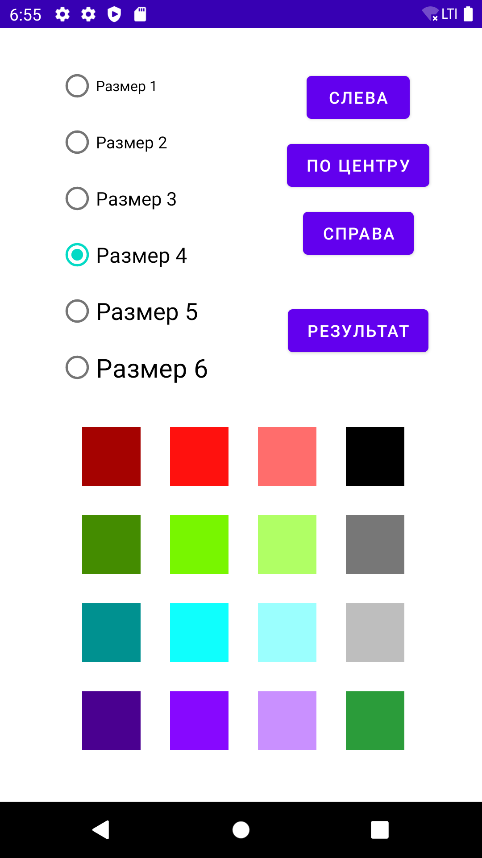 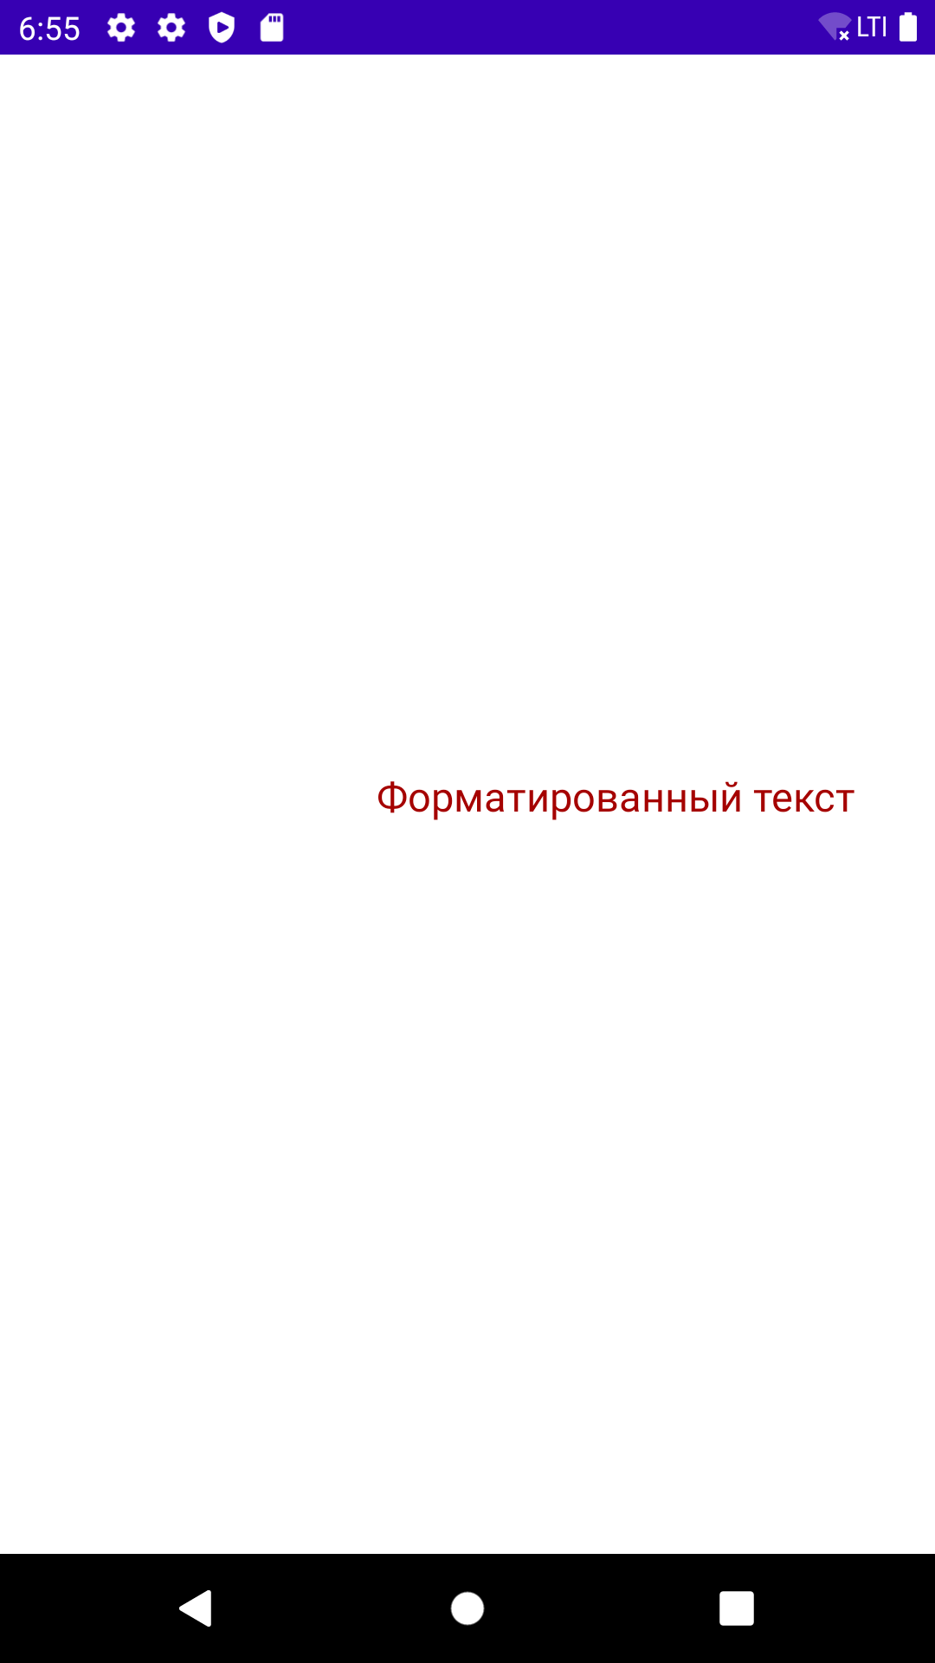**

**Рис. 1.** Первая версия

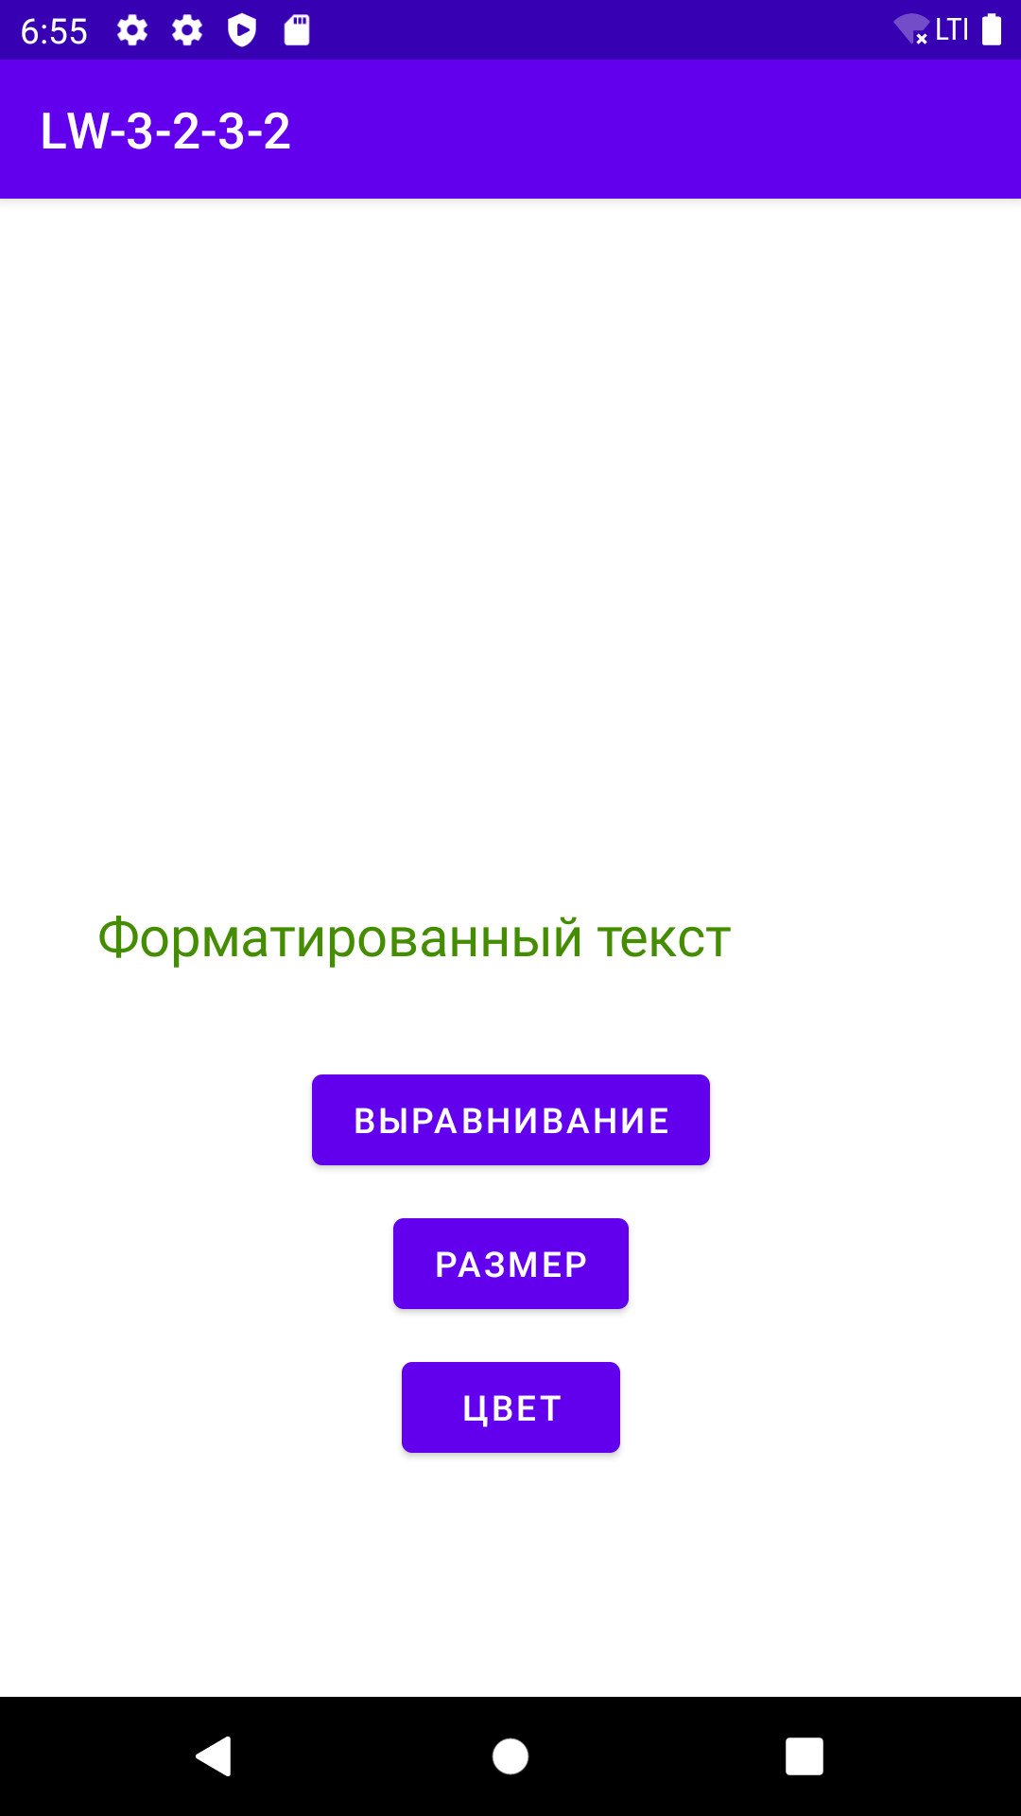 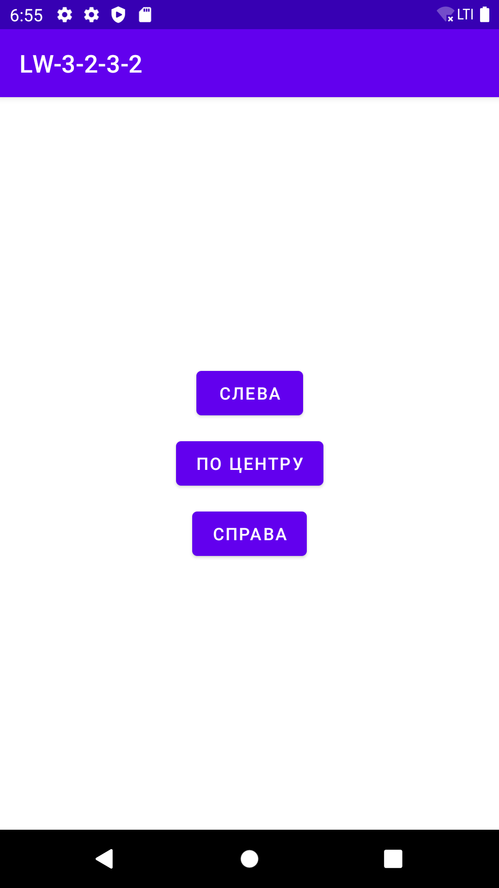 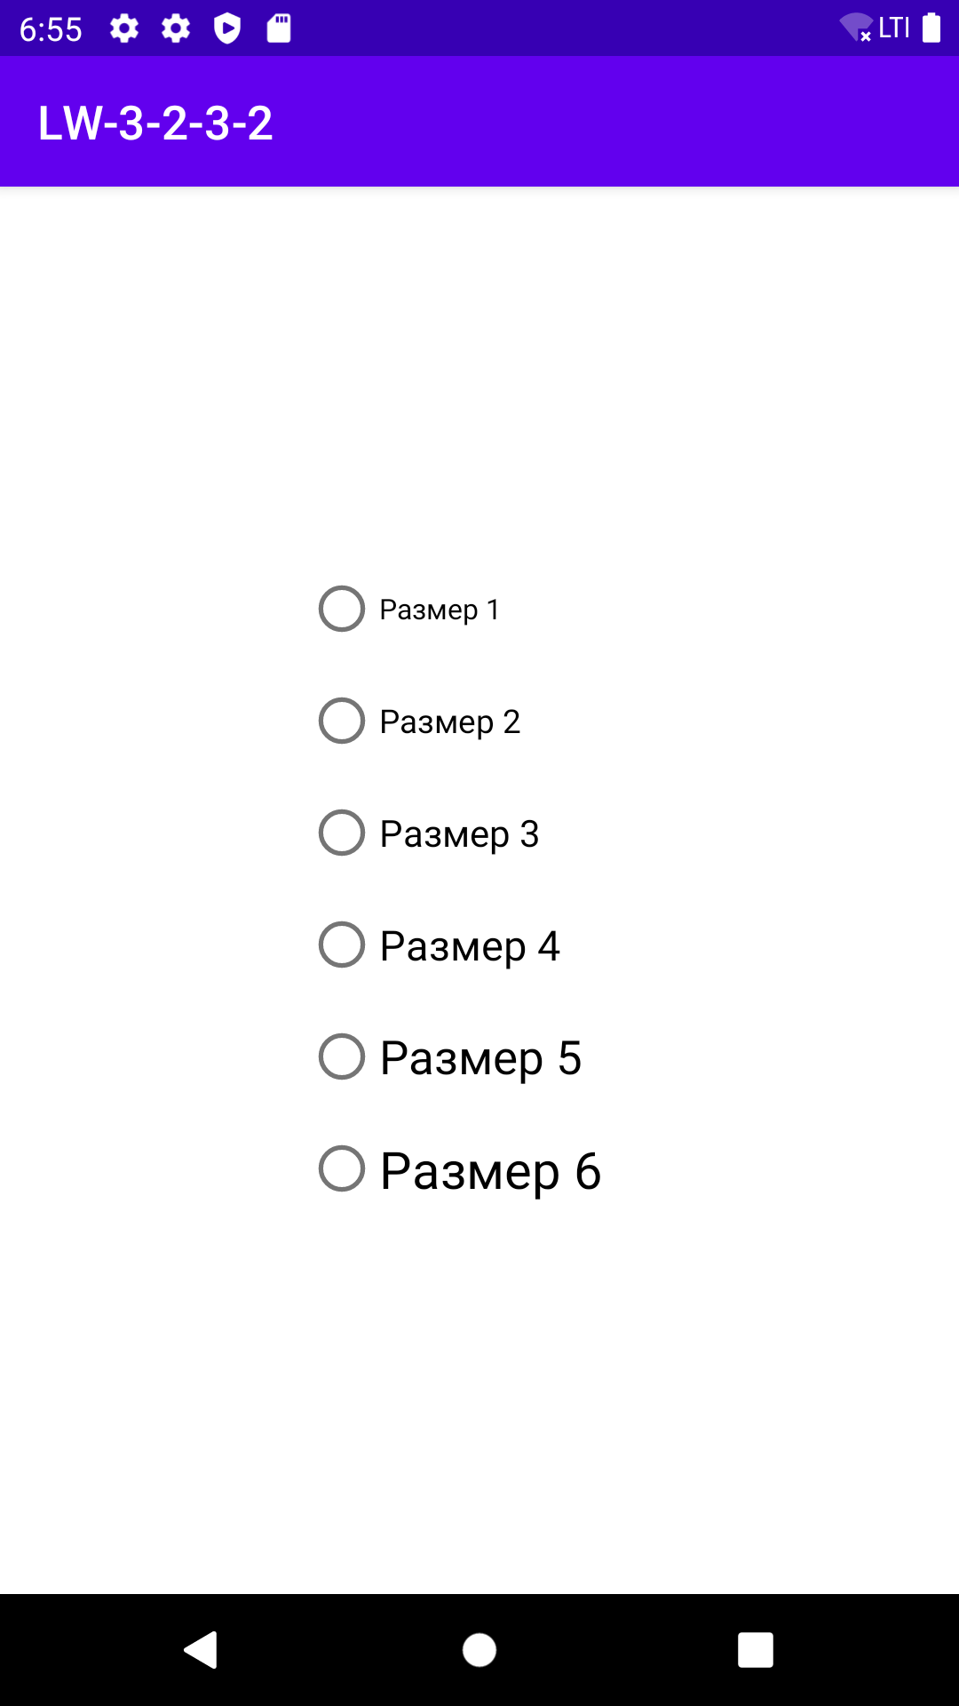 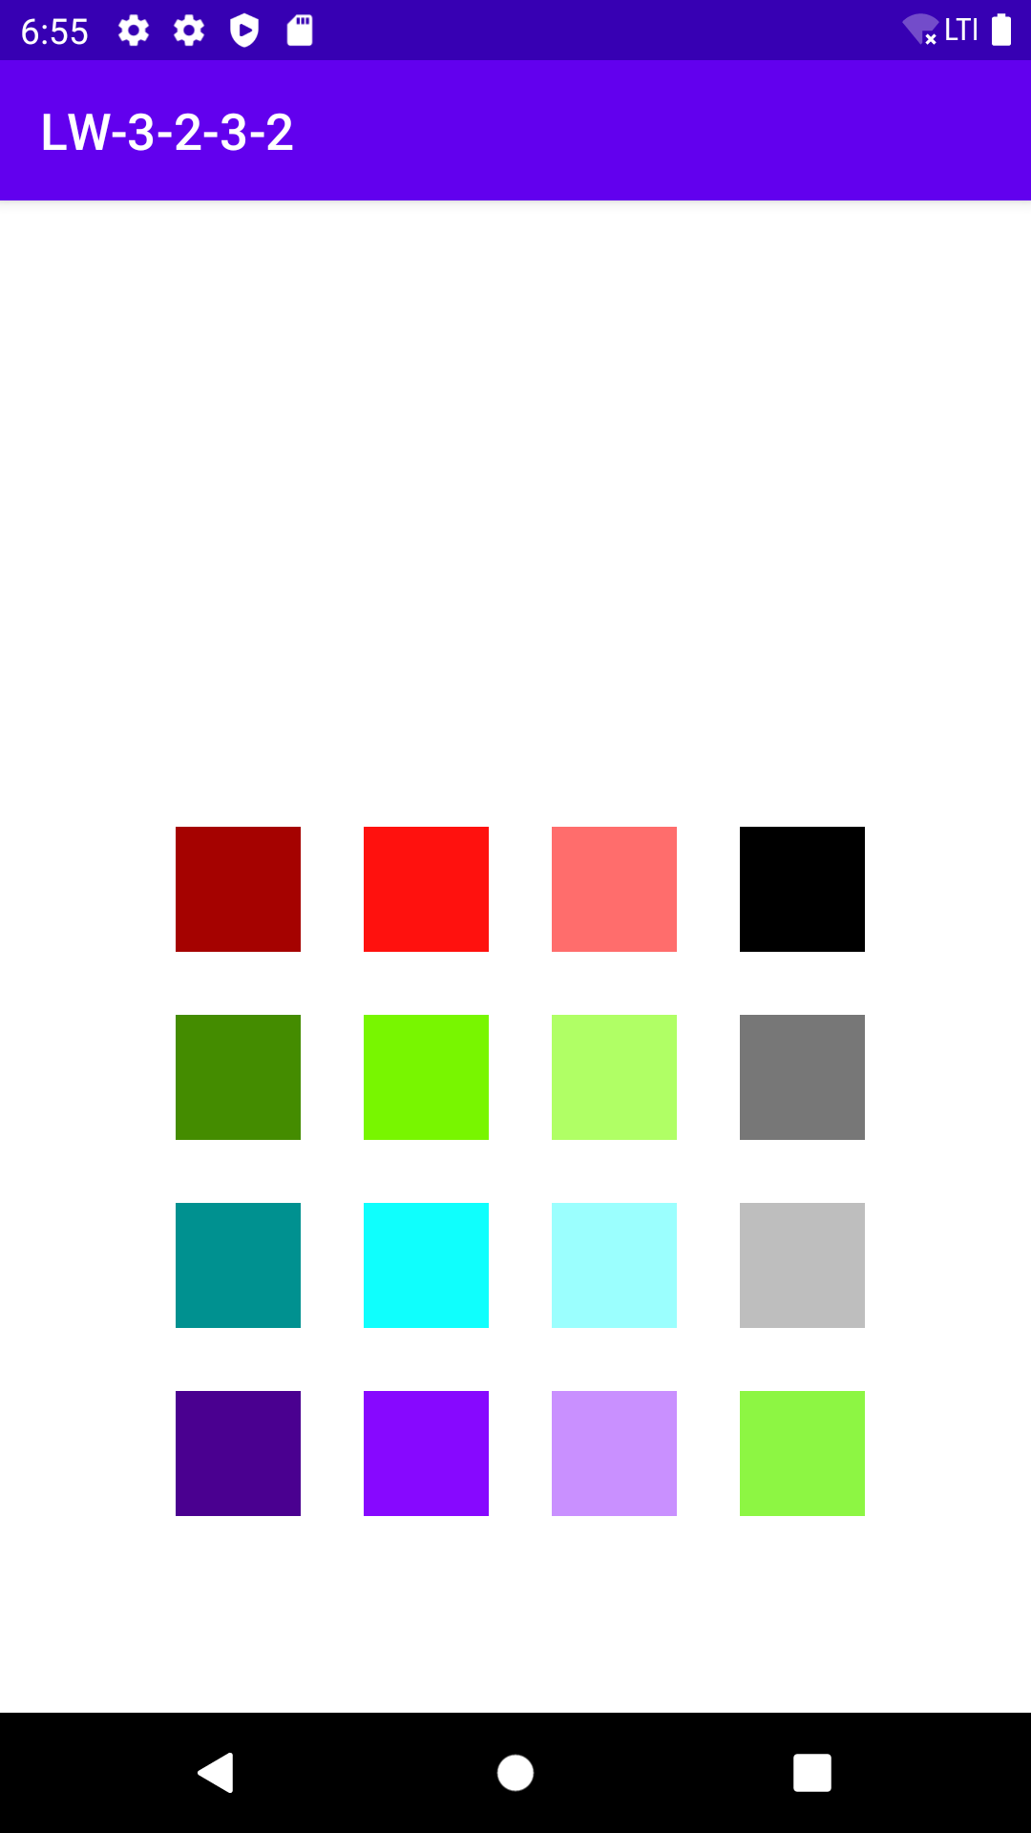

**Рис. 2.** Вторая версия

**Вывод:** в ходе выполнения лабораторной работы были получены практические навыки разработки приложений с несколькими Activity и Intent-объектами.